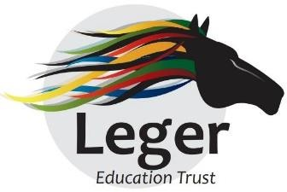
Pupil Premium Impact Report- 2023-2024 Askern Moss Road Infant Academy

Intended Outcome 1
Improved oral language skills and vocabulary among disadvantaged pupils, which impacts on reading and writing standards.
Success Criteria Outcome 1
Increased % of pupils meeting the standard of the Phonics Screening Check.
Year 1 Phonics Screening Check Outcomes

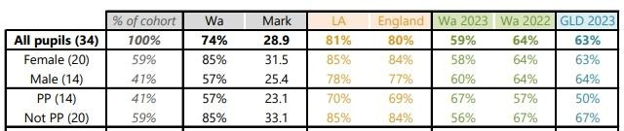
- 57% PP children attained the Y1 Phonics Screening Check.
- This figure is 12% below PP pupils nationally.
Year 2 Phonics Resit Outcomes

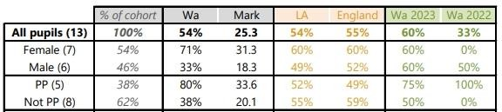

- 80% PP children attained the Y2 Phonics Resit.
- This is 31% above the national figure.
Reading Outcomes KS1

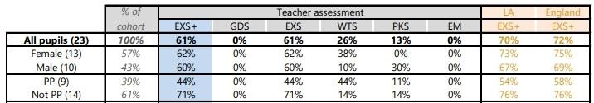
- 44% of PP children achieved the expected Y2 standard in reading compared to 58% of PP children nationally.
- There is a gap between PP children and non PP children making expected progress in Reading.

Writing Outcomes KS1

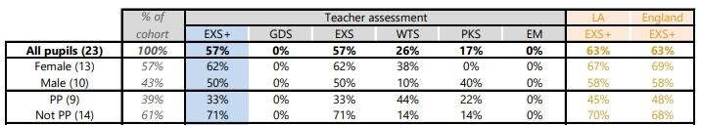

- 33% of PP children achieved the expected Y2 outcome in writing which was 15% below national.
Intended Outcome 2
For all pupils to have improved resilience through access to wider opportunities that will impact positively on learner behaviours and pupil outcomes
Success Criteria Outcome 2
Pupils have engaged in a wide variety of activities and opportunities in each year group as part of our Aspire curriculum.
Our Aspire curriculum aligns with our PSHE curriculum and curriculum plans reflect opportunities for wider learning such as road safety and inter-generational learning opportunities.
Outdoor learning is accessed regularly and supports all subjects.
School is proactive in engaging with external providers and seeking out opportunities where possible.
Intended Outcome 3
To achieve and sustain improved wellbeing for all pupils in our school, particularly our disadvantaged pupils.
Success Criteria for Outcome 3
To increase the % of PP children attending our wider-curriculum offer through lunchtime and after-school clubs.
PP attendance at extra-curricular clubs has been tracked and shows that 74% PP children accessed additional clubs during 2023-2024.
To ensure the school has a qualified Mental Health Lead.
The SENDCo attained the Mental Health Lead qualification during 2023-2024.
Intended Outcome 4
To achieve and sustain improved attendance for all pupils, particularly our disadvantaged pupils.
Success Criteria for Outcome 4
To increase overall attendance in the academy and the attendance of the PP children, bringing PP attendance in line with the attendance of non PP children.

- The gap between the attendance of PP children and non PP children narrowed; the attendance of PP children was 88.1% compared to 89.0% of non PP children.
Intended Outcome 5
To improve the engagement of all parents and carers in home learning.
Success Criteria for Outcome 5
A consistent approach to promoting reading at home has raised the profile of reading and as a result, more pupils now read at home.
- The ReadWriteInc portal is being used consistently by staff to promote reading to parents.
- Parents are provided with QR codes to support their children’s reading by providing a link to reading lessons.
- Reading workshops are delivered to parents.
- Phonics Booster sessions have been held and parents encouraged to ensure their children attend. 100% support for these sessions by parents was key in 74% of children overall passing the Y1 Phonics Screening Check; an increase from 59% in
2022-2023.

