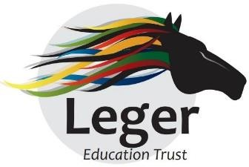
Pupil Premium Impact Report 2024-2025
Askern Moss Road Infant Academy
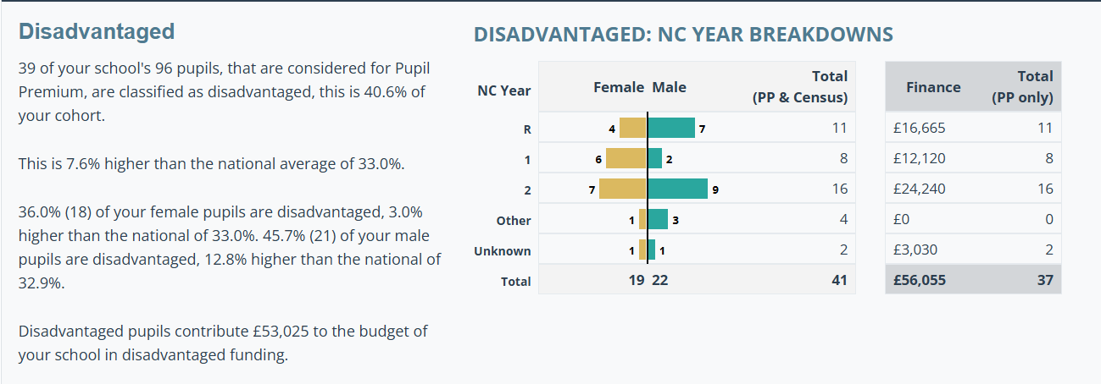

What is the Impact Report telling us? What do we need to do next?
- Outcomes for disadvantaged pupils demonstrate an improving picture, however this requires further improvement and acceleration. Quality of Education in EYFS and individualized interventions must be a priority.
- Disadvantaged pupils continue to do less well than their peers in the Phonics Screening Check (Yr1) and the Phonics Screening Check Retake (Yr2). Earlier intervention is required, beginning in F2 and continuing through KS1.
- The end of KS1 achievement of disadvantaged pupils compared to those locally and nationally has closed to within 2%. Efforts should continue to further tailor the curriculum to meet the complex needs of this group and close the gap between PP and non-PP.
- Disadvantaged pupils achieve better in Maths overall. Reading and, in particular, Writing, are the poorer subjects. Writing Champion to look in to this, to understand why it’s happening and plan strategies to address.
- Oracy skills are not as developed as we would like, therefore oracy to remain high priority for the academy. EYFS staff to disseminate knowledge of eLIP intervention. Phonics and Oracy Champion to develop a whole academy Statement of Best Practice and Progression Grid to support all staff.
- Enhancements to the curriculum to continue with a wider range of after-school provision. PSHE Champion to create a Personal Development Curriculum and link with the Junior Academy.
- Levels of independence are variable and require a consistent approach and set of expectations adhered to by all staff.

Intended Outcome 1
Disadvantaged pupils make at least expected progress from their individual starting points in all areas of the curriculum especially in reading, writing and mathematics. The gap is narrowed in the progress and attainment of PP and non-PP children
Success Criteria Outcome 1
Three-year trend in outcomes:
Good Level of Development (F2) Outcomes
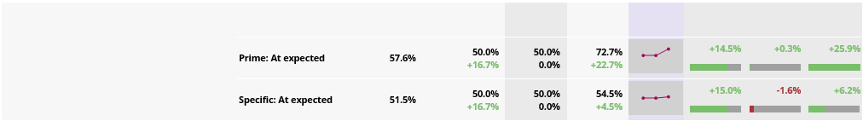
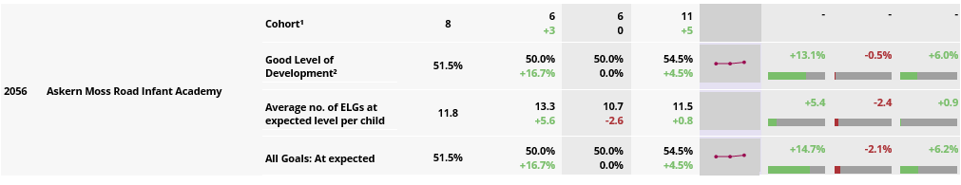

Phonics Screening Check (Yr1) Outcomes
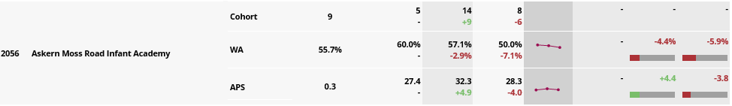

Phonics Screening Check (Yr2 Retakes) Outcomes
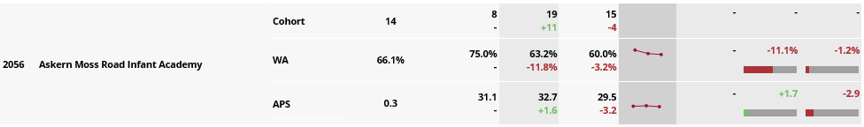
KS1 Outcomes
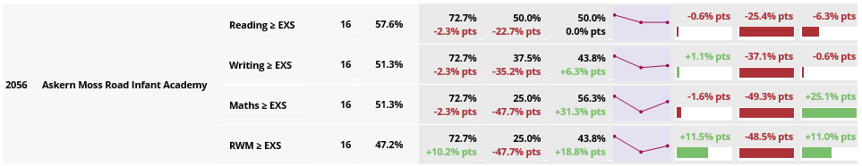

Intended Outcome 2
Improved oral language skills and vocabulary among disadvantaged pupils, which impacts on reading and writing standards. A reading culture is in place that ensures all children read regularly and a love for books is developed. Children are confident and able to speak well to a range of audiences and for different purposes.
Success Criteria Outcome 2
- Pupils have engaged in a wide variety of activities and opportunities in each year group as part of our Aspire curriculum.
- External visits and visitors attending the academy has supported increased opportunities for speech development.
- Increased financial commitment to expanding topic-based reading materials
- RWI phonics scheme is fully embedded
- Oracy and reading workshops delivered to parents/carers
- Choir performance at local church St Peters

Improvement in this area has been mixed. Multiple factors influence the progress of pupils including various vulnerabilities, parental engagement and leadership. Further work is required to embed and improve provision.
Intended Outcome 3
Achieve and sustain improved attendance for all pupils, particularly our disadvantaged pupils.
Success Criteria for Outcome 3
- Improved academy attendance from 89.3% to 91.5%
- PA decreased from 44.8% to 27.6%
- PP attendance (36 pupils at EoY) – 2% increase from previous year at 90.2
- Current strategies working well. Staff have sound knowledge of the pupils and families and support them well.

Intended Outcome 4
All children have the opportunity for further education within the home and beyond the school. Pupils love learning and have access to an engaging, broad and varied curriculum. All pupils are exposed to a breadth of experiences that allow them to contextualise their learning.
Success Criteria for Outcome 4
- Phonics Resources to take home
- Reading books (Home Readers)
- Choir Club
- Multi-Sports Club
- Gymnastics Club
- Basketball Club
- Cricket Club
- Skip2Bfit
- Chicks Experience
- Butterfly Experience
- Conisbrough Castle visit
- Victorian themed event and visit to Cannon Hall Farm and Museum
- Yr2 CAST Theatre trip
- Engagement in Leger Sport competitive events throughout the year

Intended Outcome 5
All pupils will have positive attitudes to learning, displaying good self-organisation skills, resilience and determination. They will be able to work independently with confidence.
Success Criteria for Outcome 5
- By Yr2, the majority of pupils demonstrate a good level of resilience and independence.
- All staff take on a pastoral role, particularly so with SEND pupils and those with multiple vulnerabilities.
- Pupils form positive relationships with staff and bond particularly well to those they interact with most often.
- As part of the Personal Development curriculum review, staff will further consider expectations of PD moving on from the birth to Five Matters Curriculum used in EYFS.

