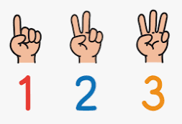
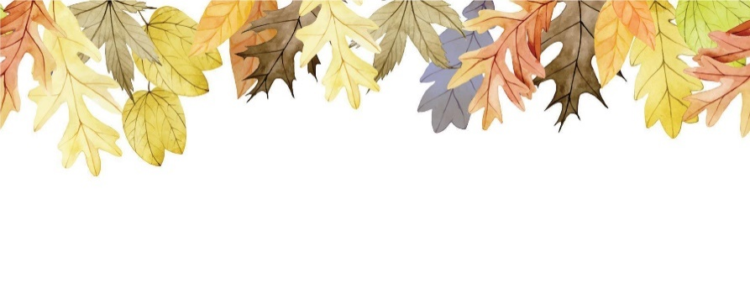
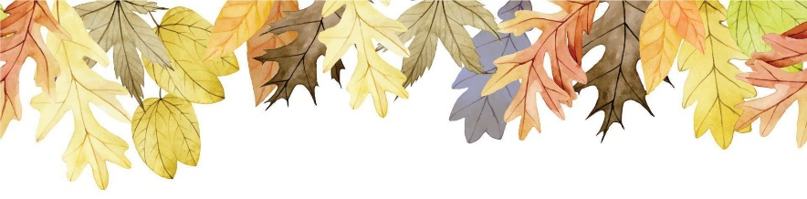
Early Literacy, Communication and Language
This half term the children will be learning to:
- Make marks and talk about them.
- Recognise familiar logos and labels within then environment.
- Know that text has a meaning.
- Begin to understand that text is read from left to right and top to bottom in English.
- Name and talk about the different parts of a book, e.g front cover, back cover, spine and pages.
- Sing a range of nursery rhymes and recall the words and actions.
- Talk about the different characters in a story and what they are doing.

Talk to your child as much as you can and share books together.

Maths

This half term the children will be learning how to:
- Subitise amounts to 3
- Recite numbers past 5
- Count up to 5 objects at one time
- Explore and talk about 2D shapes
- Talk about and create patterns
- Show amount using their fingers

Counting everyday objects at home and recognising numbers and shapes when you are out and about will be extremely helpful for your child’s mathematical development.

Juniper Class
Curriculum Newsletter
Autumn One
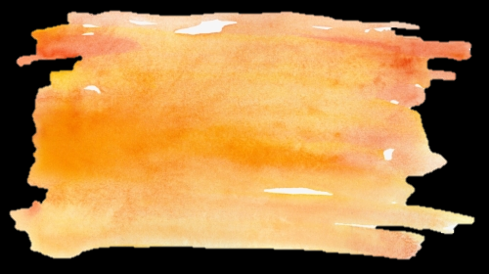
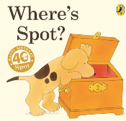
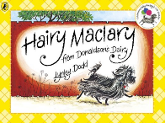
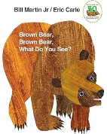
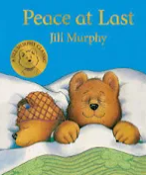
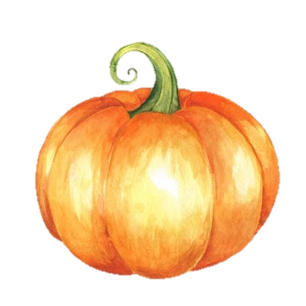
25th September
15th October
21st October

MacMillian Coffee Morning
Animal Club Visit
Harvest Stay and Play
Dates for your diary . . .
Literacy
This half term our key texts will be: Brown Bear, Brown Bear, What Do You See?
By Bill Martin Jnr /Eric Carl
Peace at last
By Jill Murphy

Hairy Maclary from Donaldson’s Dairy
By Lynley Dodd
Where’s Spot?
By Eric Hill

By

Please read picture books to your child regularly to support their understanding of story, rhymes and print and continue to enjoy singing nursery rhymes with your child.

Last day of term:
Friday 23rd October 2026

Music
In our music lessons over the next few weeks your child will be listening to a variety of songs and pieces of music. They will also be learning to clap and move in time to a piece of music and to learn the following songs:
Pat-a-Cake, Name Game, 1,2,3,4,5, This Old Man, 5 Little Ducks
Expressive Art and Design
This half term our focus will be:
- To take part in simple pretend play.
- Exploring different ways of drawing, painting and printing.

Please note that the children all have their own board space in the nursery where all of their work is displayed and celebrated. Any pieces of work will be sent home at the end of each half term.

Jigsaw (PSHE)
At Moss Road, we take great pride in ensuring that we create well-rounded, happy and confident children who are ready to learn.
This half-term, our Jigsaw focus will be ‘Being me in my world’. Through this topic we will explore some important issues including how we are the same / different from each other, friendships and feelings.
RE
The children will be learning how to work as part of a group, taking turns and sharing fairly, understanding that groups of people need agreed values and codes of behaviour, including adults and children, to work together harmoniously. Children listen with enjoyment to stories, songs and poems from different communities and traditions and respond with relevant comments, questions or actions.
If you have any questions about how Religious Education is taught to your child, your child’s class teacher would be happy to discuss this.

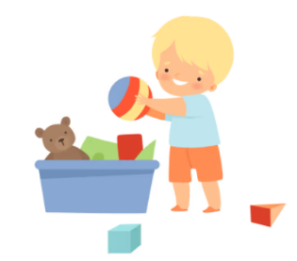

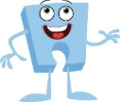
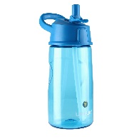
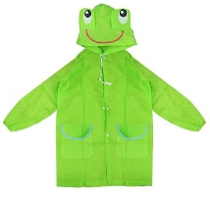
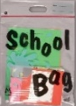
Understanding the World
This half term we will be learning about ‘Special People’. The children will talk about their families, friends and role models and discuss why they are special to them. The children will learn how we change from a baby to an adult and our families. We will also be exploring maps and looking at our local area. As well discussing seasonal changes throughout the term.

Physical development
This half term the children will be learning:
To show independence with eating and drinking.
To take care of toileting needs with growing independence.
To begin to show a preference for a dominant hand.
To know about personal hygiene and the importance of being clean and tidy.
To know that washing hands is important after using the toilet and before we eat.
To use and manipulate different tools and objects
To move around safely in different ways

Daily Essentials:
A water bottle – please do not put juice in your child’s bottle, only water please.
Please bring your child’s coat and their jumper or cardigan. Please ensure your child’s name is written in all their belongings.
Your child’s book bag containing their snuggle book, this will be changed every Friday. They will receive this very soon!

