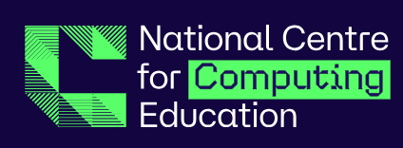
Computing: Curriculum Overview

Curriculum Sequences
Our computing knowledge and skills are covered through the NCCE programme to ensure that children are taught the appropriate content to support their development. Our teaching of Computing is progressive. The Teach Computing curriculum is a spiral curriculum with units building progressively from year to year. The curriculum is structured into 6 units for each year group, and each unit is broken down into lessons. Below shows the 6 units, which are covered:
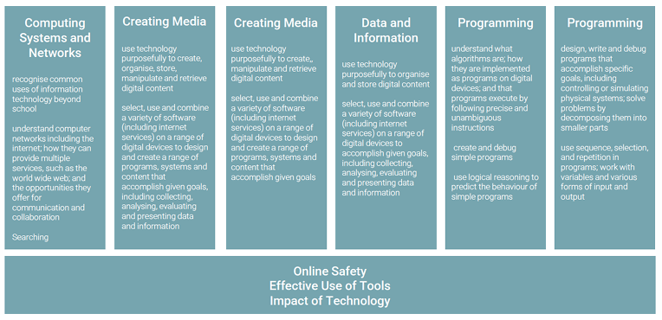

Computer Science
Computer Systems and Networks: The Computer Systems and Network unit build on the prior learning from the year before and is sequenced progressively throughout the primary phase. The graphics below show how the unit spirally progress from year to year.

Programming:
Our curriculum incorporates two programming units: Programming A and Programming B, to highlight the emphasis of Computer Science statements in the national curriculum. Programming is revisited twice within a year, with unit B progressing from what they have learnt from unit A. Within Key Stage 1, they look at two different formats: Beebots and Scratch Junior. The learning from Year 1 is built upon in Year 2.

Progression:
Early Years  Using technological toys, operating  basic digital equipment,  understanding the internet,  programming simple toys with  instructions. | Year 1  Identifying technology and computers, creating digital content, understanding algorithms and simple programming, using technology purposefully. | Year 2  Recognising uses of IT, creating media (photography and music), debugging programs, using logical reasoning, understanding online safety.

EYFS

Whilst computing/technology is no longer a discrete area of learning in the EYFS, the foundations of computing are formed in
nursery and reception. Children can use and interact with technological toys, both real and pretend for
instance as part of their role play. There are also more discrete computing learning opportunities linked with other areas of
learning, for instance what the internet can be used for and the importance of using it safely.

Computing in Nursery | Computing in Reception
Knowledge  Develop awareness that the internet can be used to  find things out.  Complete a simple programme on an electronic  device | Knowledge  Know that information can be retrieved from books  and digital devices.  Understand programmable toys follow a series of  instructions to move.  Use interactive technology to interact with apps and  games e.g. iPads and whiteboards
Skills  Show an interest in technological toys with knobs  and pulleys, real objects such as cameras and  touchscreen devices.  Acquire basic skills in turning on and operating basic  digital equipment.  Operate mechanical toys  Show skill in making toys work by pressing parts or  lifting flaps.  Play with a range of materials to learn cause and  effect | Skills  Use information books and other sources (with adult  support and guidance) to find out facts and relay  these facts to others.  Use simple tools to affect changes to materials.  Programme a toy with simple instructions to move in  a desired way.  Develop their own ideas through experimentation  with diverse materials.  Explore how different toys work and move
Key Vocabulary  On, off, battery, switch, button, phone,  camera, iPad | Key Vocabulary:  Backwards, forwards, instruction,  internet, search, website, choose, electricity
End points :

By the end of EYFS, pupils will:
Be able to explore technology in a safe and often child-led way developing a familiarity with equipment and vocabulary allowing them to have a strong start in Key Stage 1 computing and all that it demands. Computing in EYFS is centred around play-based, unplugged activities that focus on building pupils’ listening skills, curiosity, creativity and problem solving. Pupils will be able to take a photograph with a camera or table, play games on the interactive whiteboard or on iPads, use a BeeBot, watch video clips and listen to music.

Key Stage 1
Computing Aspect of the National Curriculum KS1
Computer Science | Information Technology | Digital Literacy- including e-safety
Understanding what algorithms are; how they are implemented as programs on digital devices; and that programs execute by following precise and unambiguous instructions.  Create and debug simple programs Use logical reasoning to predict the behaviour of simple programs | Use technology purposefully to create, organise, store, manipulate and retrieve digital content | Recognise common uses of information technology beyond school.  Use technology safely and respectfully, keeping personal information private;  Identify where to go for help and support when they have concerns about content or contact on the internet or other online technologies

Year 1
Autumn Term |  | Spring Term |  | Summer Term
Technology Around Us  Recognising technology in school and using it responsibly | Digital Painting  Choosing appropriate tools in a program to create art and making comparisons with working non-digitally | Moving a Robot  Writing short algorithms and programs for floor robots and predicting program outcomes | Data and inform  Exploring object labels, then using them to sort and group objects by properties. | Creating Media  Digital Writing Using a computer to create and format text before comparing to writing non-digital. | Programming animations  Designing and programming the movement of a character on screen to tell stories  Scratch junior app iPad and Chrome extension https://jfo8000.github.i o/ScratchJr-Desktop/

Year 2
Autumn Term |  | Spring Term |  | Summer Term
Information  Technology Around  Us  Identifying IT and  how its responsible  use improves our  world in school and  beyond | Digital Photography  Capturing and  changing digital  photographs for  different purposes | Robot Algorithms  Creating and  debugging programs  and using logical  reasoning to make  predictions | Pictograms  Collecting data in tally  charts and using  attributes to organise  and present data on a  computer | Making Music  Using a computer as a  tool to explore  rhythms and melodies  before creating a  musical composition  Chrome Music Lab  Chrome Music Lab  (chromeexperiments.com) | Programming  Quizzes  Designing algorithms  and programs that  use events to trigger  sequences of code to  make an interactive  quiz  Scratch junior app  iPad and  Chrome extension  https://jfo8000.github.i  o/Scratch-Desktop/

Key Concepts and End Points for KS1:
Key Concepts

• Online Safety
• Information Technology (IT)
• Computational Thinking
• Programs
• Computer skills

End Points

• Children will understand and apply the fundamental principles and concepts of computer science including logic, algorithms and data representation.
• Children will analyse problems in computational terms and have repeated practical experience of writing computer programs in order to solve such problems.
• Children will evaluate and apply information technology, including new or unfamiliar technologies, analytically to solve problems.
• Children will be responsible, competent, confident and creative users of information and communication technology.
• Children will be able to use technology safely & respectfully and understand how to keep personal information private.

